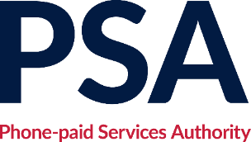

**Minutes**

**Board resolution (by correspondence)**

**Thursday 12 December 2024**

**Phone-paid Services Authority, Riverside House, 2A Southwark Bridge Road, London SE1 9HA**

David Edmonds (Chair)

Meg Munn

Winnie Palmer

Jo Prowse

Mark Thomson

|  |  |
| --- | --- |
|  | **Resolution** |
|  | In light of the transfer of regulatory responsibility to Ofcom on 1 February 2025 and the requirement for the company’s 2024/25 accounts to be audited by the National Audit Office after that date, the Board therefore resolved that:   * David Edmonds, Mark Thomson and Winnie Palmer to stand down as board members and company directors when their terms of office expire on 31 January 2025; * Meg Munn to remain in place as a board member (and become chair) and company director; * Jo Prowse to be re-appointed a board member and company director on 1 February, following expiry of her current role as Chief Executive on 31 January 2025; * Following the laying of the 2024/25 accounts before Parliament (planned for May 2025), Ofcom (or a representative from Ofcom) to be appointed as a company director following which both Meg and Jo to promptly resign. From this point Ofcom to be the sole remaining company director. It is understood that Ofcom will seek to dissolve the company at the earliest opportunity thereafter; * Ofcom to be notified of these arrangements. |